Desining Digital Repository For An Institution

A.Barveen,

*Assistant Professor, Department of Computer Science and Engineering, M.I.E.T. Engineering College,*

*Trichy, Tamilnadu,*

*barveen87@gmail.com*

A.Barveen,

*Assistant Professor, Department of Computer Science and Engineering, M.I.E.T. Engineering College,*

*Trichy, Tamilnadu,*

*barveen87@gmail.com*

***Abstract*— The library helps us learn and expand our knowledge. We develop our reading habits in a library and satisfy our thirst and curiosity for knowledge. This contributes to personal growth and development. The drawback is that public libraries have operating hours, so if an individual arrives too late, she won’t be able to access the library’s resources. People are also restricted by the amount of time they can spend with a resource, since each must be returned to the library within a set period of time. In this work, I introduced the digital library. The system that provides users with organised information and access to a repository of information and services at the knowledge base is known as a" digital library". Finally, there is a demand for high-quality content and easy access to information.The main goals and principles of the digital library are to notify students and staff about books they have taken or returned from the library. Furthermore, if the administration or staff add new books or lecture notes to the library, that message will be updated as a notification to all of us. The application's advantages include the ability for anyone to view the availability of books and copies of books in the library. In addition, everyone can read and download softcopies of books. They can check their account to see if any books must be returned and how many books must be returned. Make a request to the administrator for the requirements of the book. Staff can also update the books, materials, videos, etc. The daily newspaper is uploaded by the administrator daily in both English and Tamil. Proposing this new technology has a great impact on the present and future.**

***Keywords —Digital, E-Resources***

I.INTRODUCTION

Digital libraries are mainly stocked with sources of information that are available on the Internet in open access format, and they are remarkable for the ease of access to collections, the networking possibilities they offer, and the universal availability of their collections. These libraries are places where new digital objects are added to conventional documents already housed there he network is of great importance to libraries to tackle today’s burning issues, such as knowledge overload, user diversity, and financial crunch, whereby digital service subscription depends on consortia broader access to digital services at a consequently lower cost The term electronic library resources define the information processed and digitally driven using hardware and software that offer information that can be accessed by digital electronic users through remote information provider networks or mounted locally by digital library (DL) managers. In reality, it transfers the citadel of historically getting information to a personalized, adaptable, and synergistic culture based on information, communication, and technology (ICT).Digital libraries are mainly designed to solve specific library problems. The online collection includes DL e-books, e-newsletters, e-references, theses, and dissertation. The factors affecting user satisfaction in a DL context can be categorized as ease of access, few download exceptions, and limitations, simplicity of the DL interface design, quality of interaction process, Internet performance, quality assurance service, and ease in communication provided for by a social network [5, 6].

In terms of teaching, training, and studying, online academic libraries are important components of any university’s information infrastructure [7]. The development of DL resources is as a result of the need for people to keep their history, discoveries, and achievements records and collections [8]. Academic institutions, through their library departments, make major investments for DL resources in the area of subscription fees, information management systems, awareness, and marketing of DL resources to ensure clients are aware of the available tools and are actively using them [9]. Therefore, library users must know their information needs and make maximum use of the provided DL resources to appreciate the value of investments made by their libraries. It is not enough for academic institutions to raise students’ awareness about the use of DL tools; it is now in this context that researchers are working to improve the understanding, availability, and use of DL. According to some studies, the knowledge and use of DL around the world have revealed a range of barriers preventing learners from using online library resources.

Libraries worldwide are quickly transforming due to the ongoing growth and application of ICT. It is important to note that while the barriers to accessing DL resources may be similar in different universities, there are more in developing countries than in developed ones. The notable obstacles in literature are poor information and digital literacy skills, students’ negative attitudes towards electronic tools, poor Internet connectivity, poor ICT infrastructure, information overload, vast amounts of irrelevant information, licensing limitations on access to the DL collection, lack of generic e-resource portal interfaces, preference for print assets over electronic resources, discouraging e-resource use by academic staff, user authentication, download delay, lack of comprehensive ICT and searching skills among library staff, high cost of affordable online access, and low organizational budget for library departments.

Most library users prefer popular web search engines to library-driven systems; consequently, most library services continue to be underused. Librarians, therefore, need to adjust what they learn, how they function, and their effectiveness. Nonetheless, the absence of training for staff and other library users is a limiting factor in the accessibility and use of e-resources as users face difficulties in assessing services and the staff may lack adequate expertise to assist the users [19]. Among the e-library manager’s obstacles is that the development of a DL requires substantial investment in capital, technology, and manpower to satisfy users. Therefore, library culture has a history of resource sharing due to budget constraints that most libraries face. A library organization embraces a common goal of resource sharing and cooperation, commonly referred to as a consortium. This study is an attempt to assess the awareness, utilization, and development of electronic resources in the library by the academic community of universities. Therefore, this paper represents a critical review of DL resources taking into account the practical aspects of library services. The paper defines the criteria used in creating a DL for the university-level research community. Hence, this paper aims to review and evaluate some research works and thus determine the usability of DL services and develop a user-friendly DL discovery system to mitigate these learners’ technical hitches. Therefore, this paper reviews DL resources in the area of usability, DL development as well as ease of accessibility, and finally developed DL discovery systems. Therefore, this paper represents a critical review of DL resources taking into account the practical aspects of library services. The paper defines the criteria used in creating a DL for the university-level research community. Hence, this paper aims to review and evaluate some research works and thus determine the usability of DL services and develop a user-friendly DL discovery system to mitigate these learners’ technical hitches. Therefore, this paper reviews DL resources in the area of usability, DL development as well as ease of accessibility, and finally developed DL discovery systems.

II.CONTRIBUTIONS IN OUR PRESENT WORK

1) In Digital Repository there are no physical restrictions. It can be accessed through our own handset.

2) Students& Staff can view the books availability and no.of copies available can also be viewed on their handset.

3) New arrival books in the library are sent as notification to all the digital library users.

4) Students & Staff can send their request and also feedback.

5) Digital Library users can view their own account and the notification will send whether their taken or return the books to the library.

6) Staff can also upload their lecture notes and the journal articles,question papers, alumini project reports are available in the digital repository.

7)OTP has sent to verify the E-mail to avoid fraudlent.

The overall workflow of our architecture is shown in

Figure 1

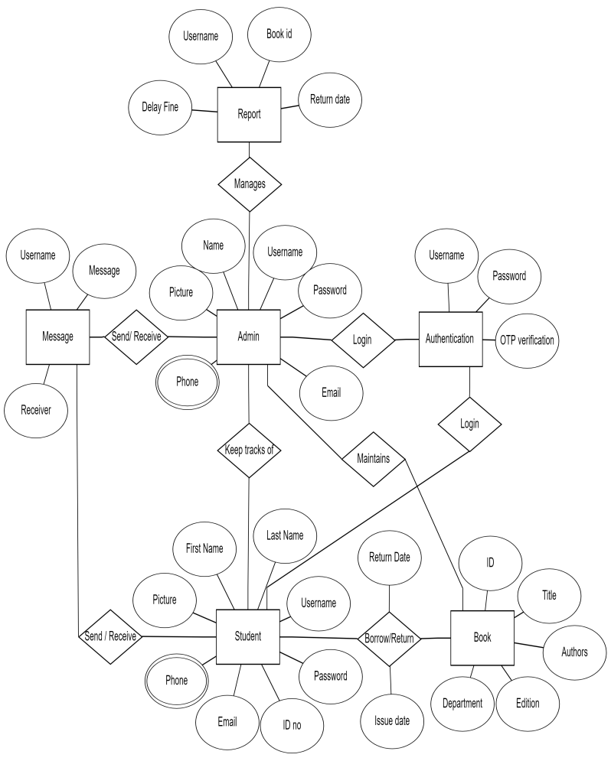

**FIGURE 1:** ER diagram of the proposed model.

III.DATASETS USED IN THE PRESENT WORK

1. *USER DATASET*

In this work, they publicly criticisies the details of library management and the library users. This database consists of a total three classes including student details, staff details and the copies of books in the library both hardcopy ,as well as softcopy. The data can be priorly stored in the database. The brief description of the above classes is presented in the figure below.

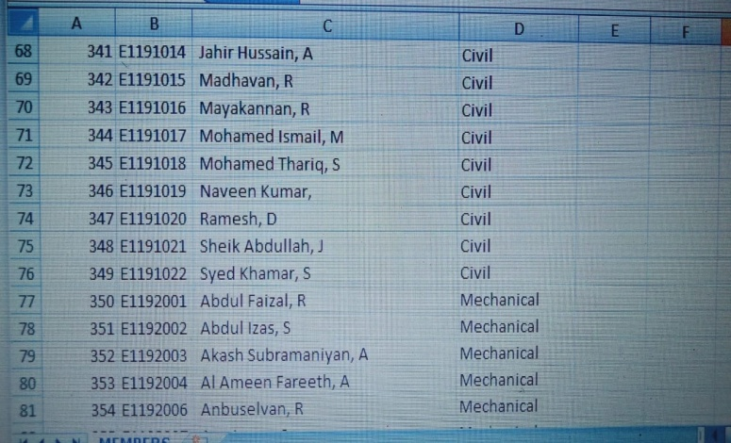.

FIGURE 2: Summary of selected dataset of student details.

The details of the digital library user’s are stored in the database. The users E-mail id, username, password , first name last name are default stored by completing the registration form. The E-mail is verified by sending the OTP to the respected E-mail to avoid the fraud. The user can be allowed to login after the registration form.

*B.BOOK DATASET*

The details of the books available in the digital library are stored in the dataset. The user can search the books by using title of the author or title of the books.

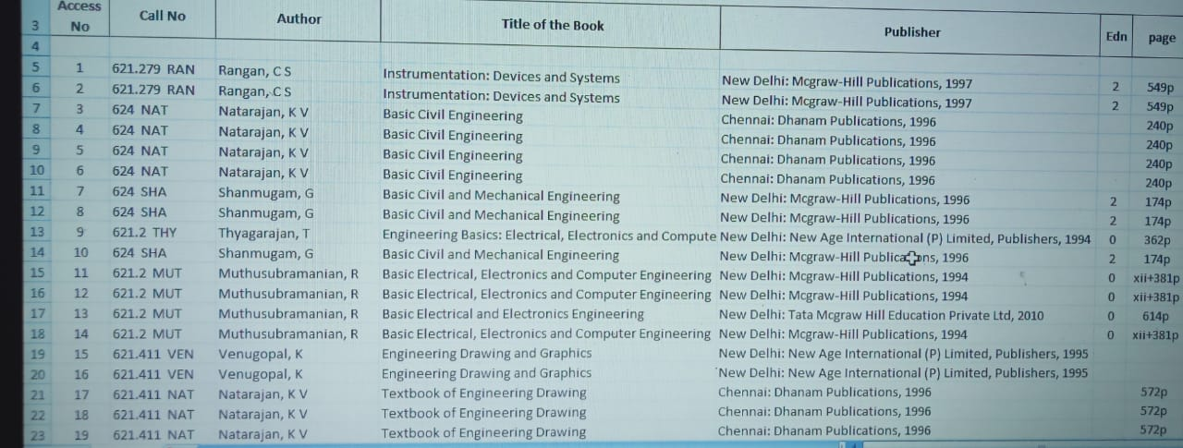

FIGURE 2:. Summary of selected dataset Book details

The user can check the availability of books and the quantity of books in the library through the handset. They can send the request for the books to the admin.

IV.METHODOLOGY

The proposed approach employs an oriented solution for the application. This application has three login pages, the student login, staff login and administrator login. At the student login they can check availability of books, books copies and they can also read and also download the required question paper, E-books, lecture notes, lab manual, etc. This system will have a soft copy of all books as per the student's requirements. These items can be chosen by the department, semester, or year. And they also view the alumini project document. These kinds of features are available through student login. Secondly, in the staff login, there are a few add-on features available, mainly so the staff can post their lecture notes, materials, books, etc. The above process is the same as Google Classroom, but it will be used for upcoming students' studies. Once the material is posted in this application, it will be valid until the syllabus changes. So, it is a very useful feature for students and also for staff, because they do not need to post the materials each semester. They can also check the availability of books and their own library account on their handset.

Finally, the major role of this application is for the admin because the entire process belongs to the admin. The admin should update the information about the library, and the newly arrived books are sent as a notification to all the digital library users. The administration stores the details of all students in the college because it is easier to identify and record whether they have taken the books, etc. The study is an analytical one based mainly on secondary sources of data like books, journals, e-journals, magazines, published and unpublished research works in their discipline. The approach described here is to create a digital repository for an institution. This technique may be used in educational institutions. The benefits of the application are that students / staff can check the availability of books and the copies of books in the library that can be viewed on their handset.

*C.PROJECT REPORT DATASET*

The alumini project reports are stored in the database. The student can make use of the report but the full text of the document can be downloaded after the registration.

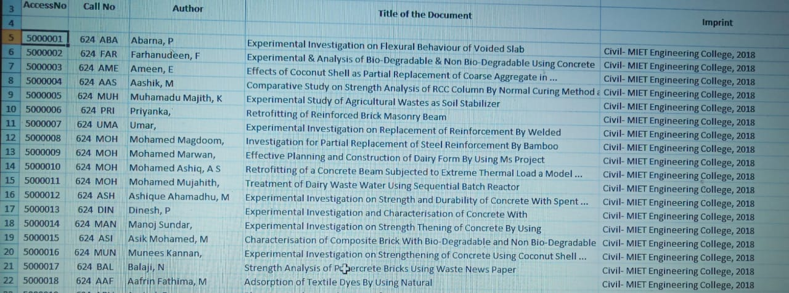

FIGURE 3:Summary of selected dataset Project report

Additionally, the user can view their library account themselves at any time. Create an application to make the library more accessible and user friendly. While the staff adds study material and study- related books, students can also request the necessary books from the administration. The time spent looking for books in the library. The demand for books, and the shortage of books are overcome by using the digital library.

1. *FRONT-END DESIGN*

By developing the digital repository using Full-stack Development. Full Stack Development refer to the development of an application from start to finish, including the front- end and the back-end. The front end consists of a user interface, and the back end takes care of the business logic and application workflow.

Front-end web development is the development of the [graphical user interface](https://en.wikipedia.org/wiki/Graphical_user_interface) of a website, through the use of [HTML](https://en.wikipedia.org/wiki/HTML), [CSS](https://en.wikipedia.org/wiki/CSS), and [JavaScript](https://en.wikipedia.org/wiki/JavaScript), so that users can view and interact with that website. [Hyper Text Markup Language](https://en.wikipedia.org/wiki/HyperText_Markup_Language) (HTML) is the backbone of any website development process, without which a web page does not exist. Hypertext means that text has links, termed hyperlinks, embedded in it. When a user clicks on a word or a phrase that has a hyperlink, it will bring another web-page. A markup language indicates text can be turned into images, tables, links, and other representations. It is the HTML code that provides an overall framework of how the site will look. HTML was developed by [Tim Berners-Lee](https://en.wikipedia.org/wiki/Tim_Berners-Lee). The latest version of HTML is called [HTML5](https://en.wikipedia.org/wiki/HTML5) and was published on October 28, 2014 by the [W3C](https://en.wikipedia.org/wiki/World_Wide_Web_Consortium) recommendation. This version contains new and efficient tways of handling elements such as video and audio files. [Cascading Style Sheets](https://en.wikipedia.org/wiki/Cascading_Style_Sheets) (CSS) controls the presentation aspect of the site and allows your site to have its own unique look. It does this by maintaining style sheets that sit on top of other style rules and are triggered based on other inputs, such as device screen size and resolution. The CSS can be added externally, internally, or embedded in the HTML tags [JavaScript](https://en.wikipedia.org/wiki/JavaScript) is an event-based [imperative programming](https://en.wikipedia.org/wiki/Imperative_programming) language (as opposed to HTML's [declarative language](https://en.wikipedia.org/wiki/Declarative_programming) model) that is used to transform a static HTML page into a dynamic interface. JavaScript code can use the [Document Object Model](https://en.wikipedia.org/wiki/Document_Object_Model) (DOM), provided by the HTML standard, to manipulate a web page in response to events, like user input.Using a technique called [AJAX](https://en.wikipedia.org/wiki/AJAX), JavaScript code can also actively retrieve content from the web (independent of the original HTML page retrieval), and also react to server-side events as well, adding a truly dynamic nature to the web page experience. Bootstrap is a [free, open source](https://www.techtarget.com/whatis/definition/Free-and-open-source-software-FOSS-or-free-libre-open-source-software-FLOSS) [front-end](https://www.techtarget.com/whatis/definition/front-end) development framework for the creation of websites and web apps. Designed to enable [responsive](https://www.techtarget.com/whatis/definition/responsive-design) development of [mobile-first](https://www.techtarget.com/searchmobilecomputing/definition/mobile-first) websites, Bootstrap provides a collection of syntax for template designs. As a framework, Bootstrap includes the basics for responsive web development, so developers only need to insert the code into a pre-defined grid system. The [Bootstrap framework](https://www.theserverside.com/quiz/12-tough-Bootstrap-5-quiz-questions-for-web-developers) is built on Hypertext Markup Language ([HTML](https://www.theserverside.com/definition/HTML-Hypertext-Markup-Language)), cascading style sheets ([CSS](https://www.theserverside.com/definition/cascading-style-sheet-CSS)) and [JavaScript](https://www.theserverside.com/definition/JavaScript). Web developers using Bootstrap can build websites much faster without spending time worrying about basic commands and functions.

*B.BACK-END DESIGN*

While Frontend Web Development is concerned with the designing of the user interface of the website using web technologies like HTML, CSS, JavaScript, etc. – Backend Web Development (or you can say Server-Side Development) is responsible for the appropriate functioning of the website. In simple words, when you visit an e-commerce website, let’s say Flipkart – the attractive layout and design of the website you see on your device are actually created by Frontend Developers but when you log in to your account, add the required items in the cart, do the payment and checkout – all these server-side functionalities comes under Backend Development*.*Most probably, after reading the above-mentioned scenario, you would have understood that Backend Development is comparatively harder than Frontend Development. It is indeed a much vaster domain than it seems.

However, things can become a bit convenient and easier for the Backend Developers if they choose the right set of backend development tools available in the tech world. These tools are programming languages, frameworks, database management systems, web servers, testing & deployment tools, and various others. You can opt-out for these tools as per your requirements while doing Backend Development. NodeJS is an open-source and cross-platform runtime environment built on Chrome’s V8 JavaScript engine for executing JavaScript code outside of a browser. You need to recollect that NodeJS isn’t a framework, and it’s not a programing language. It provides an event-driven, non-blocking (asynchronous) I/O and cross-platform runtime environment for building highly scalable server-side applications using JavaScript. One of the Node.js advantages is that developers can easily grow applications in both horizontal and vertical orientations. The applications can be horizontally scaled by adding additional nodes to the existing system.

Furthermore, during the vertical scaling of the application, Node.js allows you to add extra resources to single nodes. As a result, it is extremely scalable and offers a superior alternative to existing JavaScript servers.

*C.DATABASE DESIGN*

A database is an organized collection of structured information, or data, typically stored electronically in a computer system. A database is usually controlled by a [database management system (DBMS)](https://www.oracle.com/in/database/what-is-database/#WhatIsDBMS). Together, the data and the DBMS, along with the applications that are associated with them, are referred to as a database system, often shortened to just database.Data within the most common types of databases in operation today is typically modeled in rows and columns in a series of tables to make processing and data querying efficient. The data can then be easily accessed, managed, modified, updated, controlled, and organized. Most databases use structured query language (SQL) for writing and querying data. Structured query language (SQL) is a programming language for storing and processing information in a relational database. A relational database stores information in tabular form, with rows and columns representing different data attributes and the various relationships between the data values. You can use SQL statements to store, update, remove, search, and retrieve information from the database. You can also use SQL to maintain and optimize database performance. Structured query language (SQL) is a popular query language that is frequently used in all types of applications. Data analysts and developers learn and use SQL because it integrates well with different programming languages. For example, they can embed SQL queries with the Java programming language to build high-performing data processing applications with major SQL database systems such as Oracle or MS SQL Server. SQL is also fairly easy to learn as it uses common English keywords in its statement.

V.CONCLUSION

Digital libraries are not going to replace the physical existence of document completely but no doubt to meet the present demand, to satisfy the non local user digitization must be introduced so that at least libraries becomes of hybrid nature. The initial cost of digitization is high but experiment shows that once digitization is introduced then the cost to manage this collection will be cheaper than that of any traditional library. Day by day the cost of digitization is decreasing, the online publication is increasing, the needs of user are shifting towards a different environment so it's needless to say that after one or two years my library or your library will go to be digitized so it’s the pick time to all informational and library professional that they geared themselves to take the challenge. Although this perspective of the "digital library" is predictable because of existing library models, there remains an anachronistic quality to it. Regarding the costs, technologies, legal issues and administration of "digital libraries" militate against achieving this old paradigm vision. Given that the digital library field is still quite new, it seems strange to be talking already about enhancing digital libraries. However, in this fast-moving environment, the initial digital libraries resulting from digitization projects, or even virtual collections, are being enhanced as user expectations and technology capabilities allow. In the midst of this furious activity, it is valuable to analyze users' needs and interests and then to identify Knowledge Organization System that can be used to enhance the digital library. By going beyond the initial organization of the digital library, digital librarians can use the network environment to provide additional value to its users.

VI. REFERENCES

1. M. K. Sinha and A. Deb, “Usage of E-resources available under INDEST-AICTE consortium by library users of NIT, Silchar, Assam,” in *Proceedings of the 2015 4th International Symposium on Emerging Trends and Technologies in Libraries and Information Services, ETTLIS 2015*, pp. 191–198, Noida, India, January 2015.
2. M. K. Sinha, G. Singha, and B. Sinha, “Usage of electronic resources available under UGC-INFONET digital library consortium by Assam university library users,” in *Proceedings of the 8th International CALIBER, 2011*, Goa, India, March 2011.
3. S. C. Eze, V. C. Chinedu-Eze, and A. O. Bello, “The utilisation of E-learning facilities in the educational delivery system of Nigeria: a study of M-university,” *International Journal of Educational Technology in Higher Education*, vol. 15, no. 1, 2018.
4. P. T. C. d. O. Salvador, M. D. S. Bezerril, C. M. S. Mariz, M. I. D. Fernande, J. C. A. Martins, and V. E. P. Santos, “Virtual learning object and environment: a concept analysis,” *Revista Brasileira de Enfermagem*, vol. 70, no. 3, pp. 572–579, 2017.
5. D. Dukić and J. Strišković, “Croatian university students’ use and perception of electronic resources,” *Library and Information Science Research*, vol. 37, no. 3, pp. 244–253, 2015.
6. A. Jose, “Evaluation of digital libraries: a case study,” in *Proceedings of the International Conference of Semantic Web & Digital Libraries*, Kobe, Japan, October 2007.
7. M. Sitnicki, “Development of a model of digital research universities,” *Baltic Journal of Economic Studies*, vol. 4, no. 1, pp. 311–318, 2018.
8. I. O. Agboola, “Use of print and electronic resources by agricultural science students in Nigerian universities,” *Library & Information Science Research*, vol. 32, no. 1, pp. 62–65, 2010.
9. M. Stephen, Mudogo, and M. Stephen, “The electronic library status of digital heritage preservation management in eastern Africa status of digital heritage preservation management in eastern Africa,” *The Electronic Library Collection Building Iss Aslib Proceedings*, vol. 32, no. 3, 2014.
10. M. Koivunen and K. Saranto, “Nursing professionals’ experiences of the facilitators and barriers to the use of telehealth applications: a systematic review of qualitative studies,” *Scandinavian Journal of Caring Sciences*, vol. 32, no. 1, pp. 24–44, 2018.
11. A. G. Larson and M. Owusu-Acheaw, “Information needs of distance learners: a case of Winneba study center, University of Education, Winneba, Ghana,” *Turkish Online Journal of Distance Education*, 2016.
12. E. Matheus and A. Ruth, “Learners’ perceptions on online library resources at Namibian college of open learning,” *Information And Learning Science*, vol. 119, no. 9-10, pp. 597–606, 2018.
13. M. N. Masrek and J. E. Gaskin, “Assessing users satisfaction with web digital library: the case of universiti teknologi MARA,” *The International Journal of Information and Learning Technology*, vol. 33, no. 1, pp. 36–56, 2016.
14. J. A. Adams and S. C. Bonk, “Electronic information technologies and resources: use by university faculty and faculty preferences for related library services,” *College & Research Libraries*, vol. 56, no. 2, pp. 119–131, 2014.
15. J. Y. Hwang, J. Kim, B. Lee, and J. H. Kim, “Usage patterns and perception toward E-books: experiences from academic libraries in South Korea,” *Electronic Library*, vol. 32, no. 4, pp. 522–541, 2014.
16. D. Jotwani, “Library resources and services in Indian institutes of technology,” *Annals of Library and Information Studies*, vol. 60, no. 3, pp. 204–211, 2013.
17. A. Rubel, “Libraries, electronic resources, and privacy: the case for positive intellectual freedom,” *The Library Quarterly*, vol. 84, no. 2, pp. 183–208, 2014.
18. W. Hong, J. Y. L. Thong, W. M. Wong, and K. Y. Tam, “Determinants of user acceptance of digital libraries: an empirical examination of individual differences and system characteristics,” *Journal of Management Information Systems*, vol. 18, no. 3, pp. 97–124, 2001.
19. D. Agaba, I. M. N. Kigogo-Bukenya, and J. B. Nyumba, “Utilization of electronic information resources by academic staff at Makerere university,” *University of Dar Es Salaam Library Journal*, vol. 6, no. 1, 2011.
20. M. Ahmad and J. H. Abawajy, “Digital library service quality assessment model,” *Procedia—Social and Behavioral Sciences*, vol. 129, pp. 571–580, 2014.
21. and G. E. Hinton, ‘‘Learning to combine foveal glimpses with a third-order Boltzmann machine,’’ in *Proc. Adv. Neural Inf. Process. Syst.*, 2010, pp. 1243–1251.
22. R. K. Srivastava, K. Greff, and J. Schmidhuber, ‘‘Training very deep networks,’’ in *Proc. Adv. Neural Inf. Process. Syst.*, 2015, pp. 2377–2385.
23. Ma, ‘‘Fine-grained age estimation in the wild with attention LSTM networks,’’ IEEE Trans. Circuits Syst. Video Technol., vol. 30, no. 9, pp. 3140–3152, Sep. 2020, doi: [10.1109/TCSVT.2019.2936410.](http://dx.doi.org/10.1109/TCSVT.2019.2936410)
24. ‘‘Age progression/regression by conditional adversarial autoencoder,’’ in Proc. IEEE Conf. Comput. Vis. Pattern Recog- nit. (CVPR), Jul. 2017, pp. 5810–5818.

.